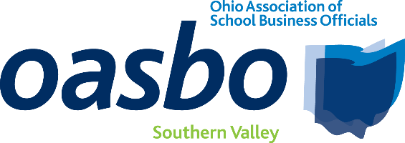
AGENDA
Southern Valley Committee Meeting

September 18, 2025
8:30 a.m. – 12:15 p.m.

LOCATION: Athens City Schools Central Office/Athens-Meigs ESC
21 Birge Drive
Chauncey, Ohio 45719

8:30 – 8:45 | Registration
8:45 – 9:00 | Committee Business  - Committee Reports
9:00 – 10:00 | Unique Financing Structures, Additional Revenue Sources, and Market Update for Ohio Schools  Speakers: Mike Burns and Mark Weekly  Managing Director; Senior Vice President – Baird Financial
10:00 – 10:15 | BREAK/Collaboration
10:15 to 11:15 | Cybersecurity as a Fiscal Responsibility: Turning Compliance into Strategy  Speaker: Kyle Yost  Account Executive - DataServ
11:15 – 11:45 | OASBO Updates
11:45-12:15 | Roundtable Discussion
12:15 | Lunch provided by DataServ/Adjourn

