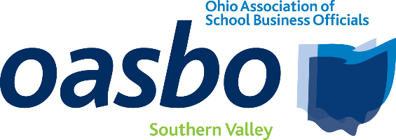
AGENDA
Southern Valley Committee Meeting

March 12, 2026
8:30 a.m. – 12:15 p.m.

LOCATION: Athens City Schools Central Office/Athens-Meigs ESC
21 Birge Drive
Chauncey, Ohio 45719

8:30 – 8:45 | Registration
8:45 – 9:00 | Committee Business  - Committee Reports
9:00 – 10:00 | Facilities Maintenance  Speaker: Trent Kaltenbach  Field Advisor – Tremco Roofing & Building Maintenance
10:00 – 10:15 | BREAK/Collaboration
10:15 to 11:15 | Property Tax Reform and Local Funding Strategies  Speaker: Paul Rutter  Partner – Bricker Graydon Wyatt LLP
11:15 – 11:45 | Artificial Intelligence and the Treasurers Office  Speaker: Kyle Yost  Account Executive - DataServ
11:45-12:15 | OASBO Updates/Roundtable Discussion
12:15 | Lunch provided by Tremco/Adjourn

