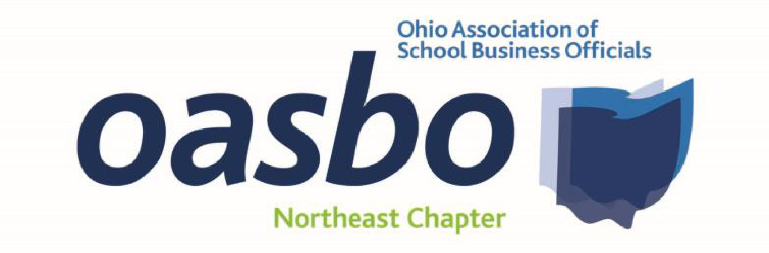

**November 4, 2025**

**NEOASBO Chapter Meeting**

**Educational Service Center of Northeast Ohio**

8:30 a.m. Welcome / Sign in

8:45 a.m. Chapter Business / Updates

9:00 a.m. 1.0* Cybersecurity (CPIM*)

*Suzy Nash – DataServ*

10:00 a.m. 1.0 Education & Community Foundations - Statutory and/or Independent

The Argument for Having Both

*Rebecca Princehorn – Bricker Graydon*

11:00 a.m. 1.0 Fund Transfers and Dormant Funds

How to Handle

*Catherine Swartz – Bricker Graydon*

*Rebecca Princehorn – Bricker Graydon*

12:00 p.m. 60 min Lunch (provided by Bricker Graydon)

1:00 p.m. 1.0 Safety and Injuring Reporting/Accident Investigation

*Wendy Sergent – Minute Men*

2:00 p.m. 1.0 TBD

*Wendy Sergent – Minute Men*

3:00 p.m. Adjourn

Five (5) Professional Development Hours – *One (1) CPIM Pending*

**This event will be free to attend and will be held in-person**

Questions? Contact Colleen Aholt, aholtcolleen@elyriaschools.org

***Reporting Contact Hours***

* Use OASBO’s Self-Reporting Tool
* Go to the OASBO website
* Log in ->
  + My OASBO ->
    - My Profile ->
      * Self-Report Event Attendance/Credits
        + Use the following picture as guide

