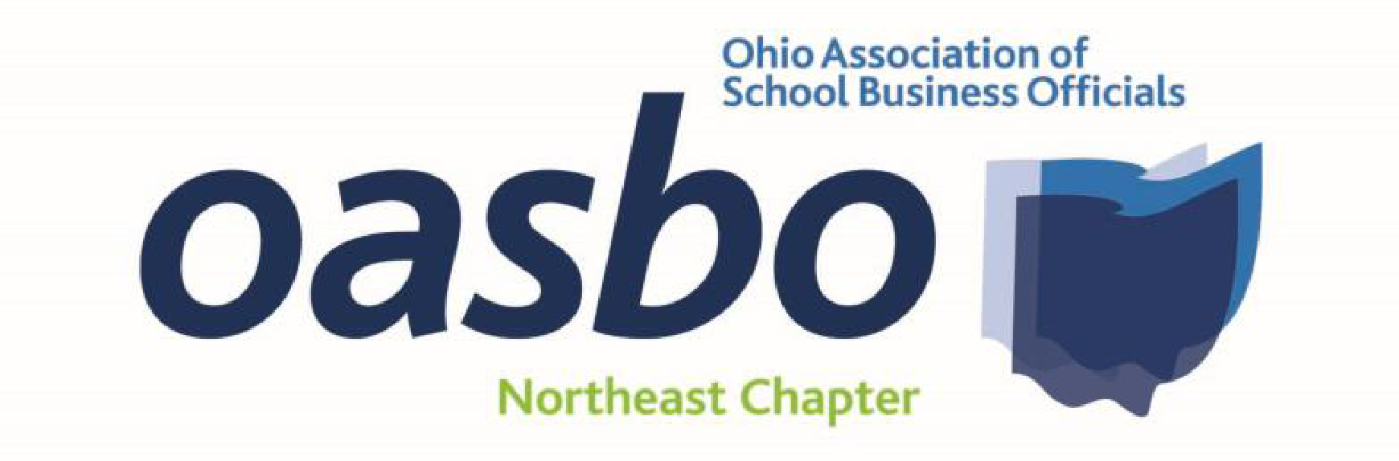

February 24, 2023
NEOASBO Chapter Meeting
Educational Service Center of Northeast Ohio

9:00 a.m. OASBO Update
Katie Johnson, Deputy Executive Director

10:00 a.m. 1.0 Fixed Income Market Effects and Economic Derivation of Inflation (CPIM)
Michael Prcela, Sudsina & Associates
Phillip Weisshaar, Stifel Public Finance

11:00 a.m. Break for lunch (provided by Frontline Education)

11:30 p.m. 1.0 Updates from Local County Auditors
Ronald O’Leary, Administrator, Cuyahoga County
Charles Walder, Geauga County Auditor
Christopher Galloway, Lake County Auditor
Craig Snodgrass, Lorain County Auditor

12:30 p.m. Break

12:45 p.m. 1.0 The Fair School Funding Plan – what you need to know (CPIM)
Ryan Ghizzoni, Frontline Education
Kent Zeman, Frontline Education

1:45 p.m. 1.0 Legal Update
Rick Manoloff, Squires, Sanders and Boggs

2:45 p.m. Adjourn

Four (4.0) Professional Development Hours

**This event will be free to attend and will be held in-person**
Questions? Contact Sean Nuccio - nuccios@parmacityschools.org (440) 885-2324

Reporting Contact Hours

- Use OASBO’s Self-Reporting Tool
- Go to the OASBO website
- Log in ->
  - My OASBO ->
    - My Profile ->
      - Self-Report Event Attendance/Credits
        - Use the following picture as guide

