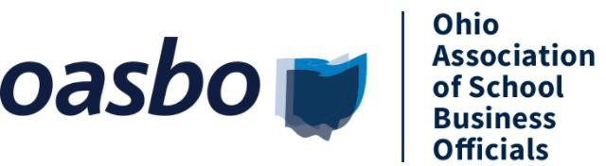 OASBO Central Chapter

Holiday Meeting

Friday, December 13, 2024

Der Dutchman Restaurant - 445 S. Jefferson Ave., Plain City, OH 43064

AGENDA

8:00 – 9:30 a.m. **REGISTRATION**

Enjoy a Der Dutchman doughnut & coffee, tea, or orange juice while you socialize with those you haven’t seen in a while.

9:30 – 10:00 a.m. **BUSINESS MEETING**

* OASBO Central Chapter Updates
  + Financial Update
* OASBO Update
* Other Business

10:00 – 11:30 a.m. GUEST SPEAKER – Chad Willett, Speaker, instructor and author

***Rip Off the Rearview Mirror:*** *Living for the only minute we can control which is ‘Now’. When we focus on the past or anticipate the future, we waste an incredible amount of energy, generate depression, and cause anxiety.*

11:30 a.m. – 1:00 p.m. Holiday Luncheon

Amish cooking served buffet style – Broasted chicken, roast beef & turkey with mashed potatoes w/gravy, dressing, noodles, green beans, creamed corn, homemade bread, salad, beverages, and a slice of pie.

**Monetary & canned food drive to benefit the Mid-Ohio Food Bank – Let’s help wipe out child hunger!**

There is a $20 per person cost for the meeting & meal. Registration deadline is December 9, 2024

Name: Title:

Name: Title:

Name: Title:

Name: Title:

District: Phone:

**Please make checks payable to Central Chapter of OASBO and send to: Central Chapter of OASBO**

**C/O Tyson Hodges 5175 Emerald Parkway**

**Dublin, OH 43017**

There are a maximum of 200 seats for this event. Reservations will be held on a first come, first serve basis.

Questions may be directed to [centralohiooasbo@gmail.com](mailto:centralohiooasbo@gmail.com)