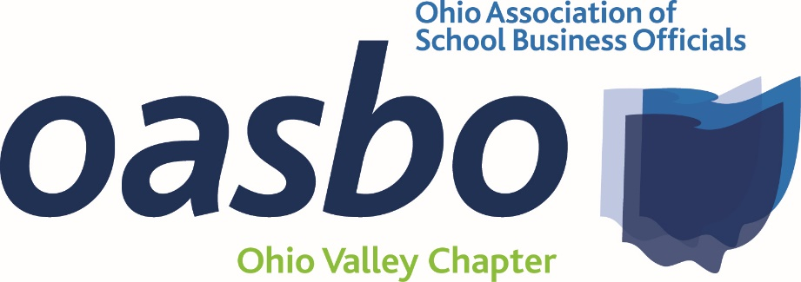
Agenda
Friday, September 16, 2022
8:30 a.m. – 1:30 p.m.
@ SWOCA
3611 Hamilton-Middletown Rd.
Hamilton, Oh 45011-2241
Agenda: 8:30 a.m. – 8:45 a.m. – Welcome
- Approval of Minutes, Financial Report
8:45 a.m. – 9:45 a.m. – Ennis Britton – Bill Deters - Legal Update/Treasurer’s Role in Negotiations
9:45 a.m. – 10:45 a.m. – RedTree – Jennifer Trowbridge/Joe Violand – Economic and Market Update (CPIM)
10:45 p.m. – 11:00 p.m. – OASBO Update – Callie Wells
11:00 a.m. – 11:45 a.m. – Lunch – Provided by the Ohio School Plan
11:45 a.m. – 12:30 p.m. – Ohio School Plan – Terra Henkle – Claims – Who Knew?
12:30 p.m. – 1:30 p.m. – Frontline Education – Stacy Overly – Cash, Sustainability, and the One-time Funding Cliff (CPIM)
1:30 p.m. - Adjourn
Registration:
- No Cost for this meeting
- We do need a count for lunch, so please RSVP by Friday September 9, 2022

