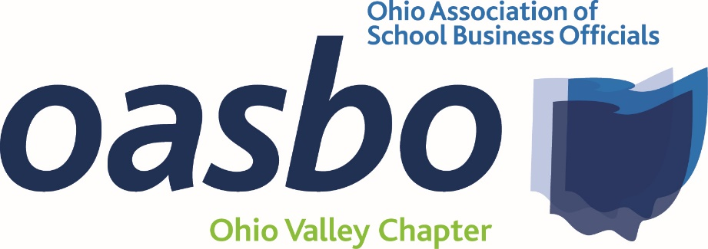
Agenda
Friday, May 20, 2022
8:30 a.m. – 1:30 p.m.
@ SWOCA
3611 Hamilton-Middletown Rd.
Hamilton, Oh 45011-2241
Agenda: 8:30 a.m. – 9:45 a.m. – Welcome
- Approval of Minutes, Financial Report, Officer Elections, Approval of Annual Membership Fee
8:45 a.m. – 9:30 a.m. – Equitable – Nory Gonzalez (CPIM)
9:30 a.m. – 10:15 a.m. –Ennis Britton – Erin Wessendorf-Wortman - Legal Update
10:15 a.m. – 11:00 a.m. – Frontline Education – Ernie Strawser/Meghan Homsher – State Funding (CPIM)
11:00 a.m. – 11:45 a.m. - Lunch
11:45 a.m. – 12:30 p.m. SWOCA Update
12:30 p.m. – 1:15 p.m. – OASBO Update – Katie Johnson
1:15 p.m. - Adjourn
Registration:
- Lunch will be provided by Equitable
- No Cost for this meeting
- We do need a count for lunch, so please RSVP by Friday May 1, 2022

