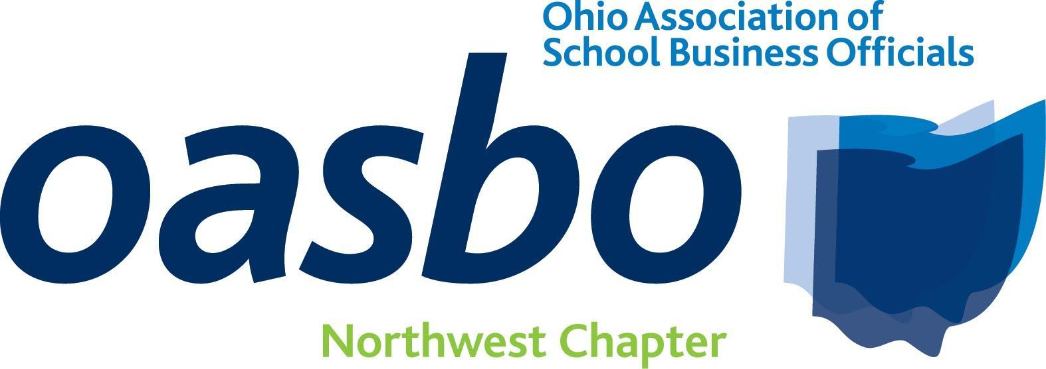 OASBO, Northwest Chapter
CPIM Meeting
March 4, 2026
Stone Ridge Golf Club, Bowling Green, Ohio

Agenda

9:00-9:25 Registration

9:25-9:30 Welcome and Introductions

9:30 to 10:30 Session 1 Doing More with Less: Investing through Funding Challenges
Ryan Nelson, Red Tree

10:40 to 11:40 Session 2 Property Tax - What We Know and How It’s Changing
Chris Kline, Lawrence County Auditor’s Office

11:45 to 12:45 Lunch Buffet / Business Meeting (Sponsored by Red Tree)

12:50 to 1:50 Session 3 The Ohio Ethics Law 2026: When Doing Right Matters
Susan Willeke, Ohio Ethics Commission

2:00 to 3:00 Session 4 Economic & Municipal Bond Market Update
Patrick King, Stiffel

3:00-3:10 Drawings and Adjourn

Individuals will still need to pay the annual certification fee ($100) to the Treasurer of State and report hours for full CPIM credit.

