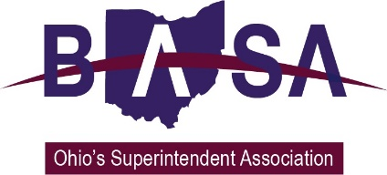

House Finance Committee

Senate Bill 235 Written Testimony

Ohio School Boards Association

Buckeye Association of School Administrators

Ohio Association of School Business Officials

November 16, 2016

Thank you for the opportunity to speak out in opposition to SB 235 on behalf of the members of the Ohio Association of School Business Officials (OASBO), the Ohio School Boards Association (OSBA), and the Buckeye Association of School Administrators (BASA).

Our organizations represent the public school boards of education, superintendents, treasurers and business managers, and other school business officials from around the state. They are the leaders charged with the fiscal responsibility and accountability of their school districts.

The Senate version of SB 235 would authorize tax exemptions for land in the pre-development stage and reduce property taxes for land purchased for re-development. We oppose the legislation as it has the potential for reducing revenue for school districts and, in some cases, require taxpayers from other commercial property to pay more than their fair share.

When one commercial property is undervalued, the other commercial properties in the school district must make up the difference. Levy millage rates are set based on the total valuation of the school district. If some properties are undervalued at the time a levy is passed, the millage rate set for the levy must be higher than necessary in order to raise the funds requested by the district. This means property owners whose real property is set at a fair value will pay more than necessary.

Ohio already has a number of economic development tax exemption tools available which are meant to achieve the economic development aspirations of local communities and the state. These are applied based on well-thought-out goals and plans developed by community leaders. The provisions in SB 235 do not achieve a cohesive, consistent economic development strategy. In fact, passage of the bill would automatically create a state-mandated exemption for taxes on the increase in value for land purchased for re-development, regardless of the local interest.

School districts will have no say in the granting of this new blanket exemption, even though the planned development may affect their revenues and potentially increase district enrollment as a result of new development in the area.

The following is a list of reasons why SB 235 should not be enacted:

- Ohio has existing local economic development tools ~ based on local needs and plans.
- SB 235 could result in inconsistent and unfair economic development practices.
- Property owners whose properties are set at a fair value subsidize those properties that are undervalued.
- SB 235 will be difficult to monitor and is vague as to who will decide when a property qualifies or when the exemption ends.

We respectfully request that you reject SB 235.

It is our understanding that several organizations representing local governments and economic development professionals have submitted proposals for improving the bill. While our members oppose the enactment of this proposed new mandated economic development tool, we would favor amendments that allow local discretion in implementation, should the bill pass.

Barbara Shaner, OASBO

Damon Asbury, OSBA

Tom Ash, BASA

